SYSTEMS AND CLASSIFICATION OF SYSTEMS

A. System Representation:

A physical system are an interconnection of components or devices or subsystems. Ex. Human body, computer, university etc.
A system is a mathematical model of a physical process that relates the input (or excitation) signal to the output (or response) signal.

Let x and y be the input and output signals, respectively, of a system. Then the system
is viewed as a transformation (or mapping) of x into y. This transformation is represented
by
where T is the operator representing some well-defined rule by which x is transformed
into y.

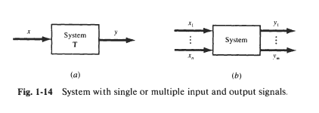
B. Continuous;Time and Discrete-Time Systems:

If the input and output signals x and y are continuous-time signals, then the system is
called a continuous-time system [Fig. 1-15(a)]. If the input and output signals are discrete-time signals or sequences, then the system is called a discrete-time system [Fig. 1 - 15(b)].
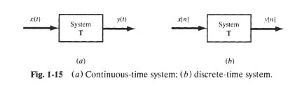

C. Interconnections of Systems:

Many real systems are built as interconnections of several subsystems.
Ex. Audio system, which is interconnection of radio receiver, CD player, Tape deck, amplifier, one or more speakers.
Their connection can be series (cascade) or parallel.

In series, the output of one system is fed to the input of other system (Fig. 2.35a). Ex. Radio signal is followed by a series of amplifiers before go to speaker.

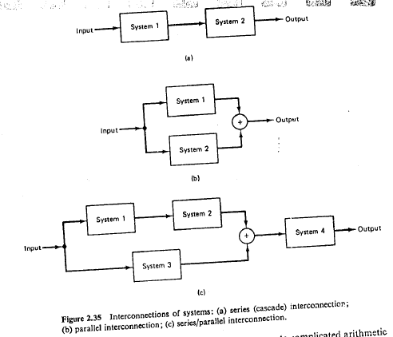

Similarly, they can be parallel (Fig. 2.35b). Here the same input signal is applied to system1 and system2. (+) denotes addition. Ex. Audio system with several microphones feeding into a single amplifier and speaker system.
System can also be series and parallel interconnections (Fig. 2.35c).
Another important type of system interconnection is a feedback interconnection- in the figure 2.37, where the output of system1 is the input to system2, while the output of system2 is fed back and added to the system1. Ex. Digitally controlled aircraft, adjust speed and location of landing.

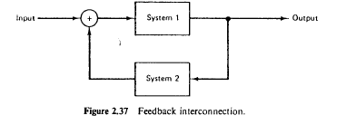

BASIC SYSTEM PROPERTIES:

A. Systems with Memory and without Memory:

A system is said to be memoryless if the output at any time depends on only the input
at that same time. Otherwise, the system is said to have memory. An example of a
memoryless system is a resistor R with the input x ( t ) taken as the current and the voltage
taken as the output y ( t ) . The input-output relationship (Ohm's law) of a resistor is

Another example: 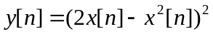 is memoryless, since the output only depends upon the present input, not past or future input.

An example of a system with memory is a capacitor C with the current as the input x( t )
and the voltage as the output y (t).

Delayed output 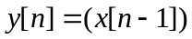is with memory system, since the output depends upon the past input.

B. Causality:

A system is called causal if its output y ( t ) at an arbitrary time 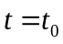, depends on only
the input x ( t ) for 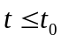. That is, the output of a causal system at the present time depends
on only the present and/or past values of the input, not on its future values.
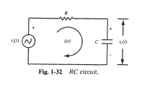

The RC circuit is causal, since the capacitor voltage responds only to the present and past values of the source voltage. The following system is causal:

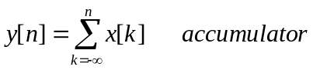
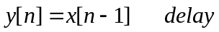```

A system is called noncausal if it is not causal. Examples of noncausal systems are

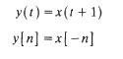
Note that all memoryless systems are causal, but not vice versa.
Application: in speech and image processing.

C. Stability:
A stable system is one in which small inputs lead to responses that do not diverge. That is A system is said to be stable in the bounded input bounded output sense (BIBO).
So a system is stable if for any bounded input x defined by

the corresponding output y is also bounded defined by

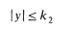
If bounded input produces unbounded output, the system is called unstable.

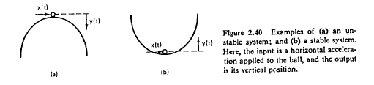

D. Time invariance:
A system is time invariant if the behavior and characteristics of the system are fixed over time. For example, the RC circuit is time invariant if resistance and capacitance values of R and c are constant over time.
For a continuous-time system, the system is time-invariant if

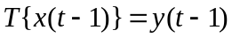
For a discrete-time system, the system is time-invariant, if
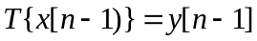

E. Linearity:

If the operator T satisfies the following two conditions, then T is called a
linear operator and the system represented by a linear operator T is called a linear system:

1. Additivity:
Given that Tx₁, = y₁ , and Tx₂, = y₂, then
for any signals x₁, and x₂.

2. Homogeneity (or Scaling):
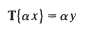
for any signals x and any scalar .

CHAPTER 2
Linear time-invariant system

Two system properties, linearity and time-invariance, play a fundamental role in signal and system analysis for two major reasons:
First, many physical processes possess these properties and thus can be modeled as linear time invariant (LTI) systems. In addition, LTI systems can be analyzed in considerable detail, a set of powerful tools that form the core of signal and system analysis.

Discrete Time LTI Systems: The Convolution Sum

The Representation of discrete-time signals in terms of Impulses
The key idea in visualizing how the discrete-time unit impulse can be used to construct any discrete-time signal is to think of discrete-time signal as a sequence of individual impulses. Let signal x[n] as in figure 2.1a. In the remaining parts of this figure, we have depicted five time shifted, scaled unit impulse sequences, where the scaling on each impulse equals the values of x[n] at the particular instant the unit sample occurs. For example

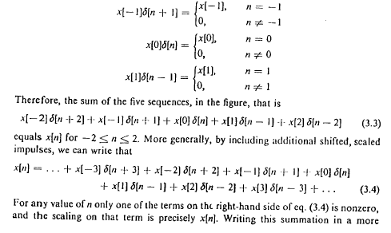
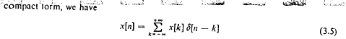

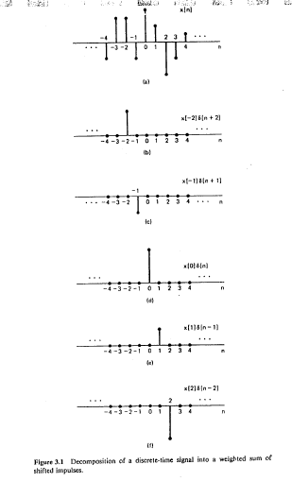

A. Impulse Response:
The impulse response (or unit sample response) h[n] of a discrete-time LTI system
(represented by T) is defined to be the response of the system when the input is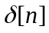, that
is,
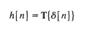

B. Response to an Arbitrary Input:
So the input x[n] can be expressed as
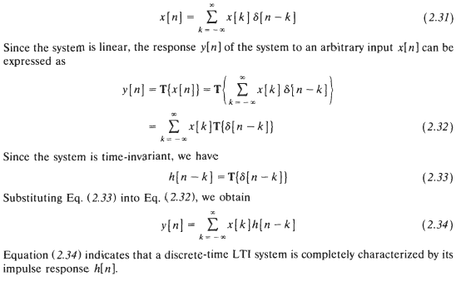

C. Convolution Sum:
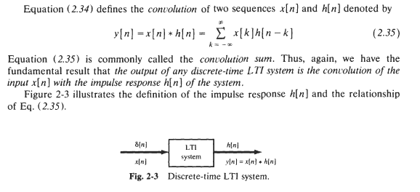
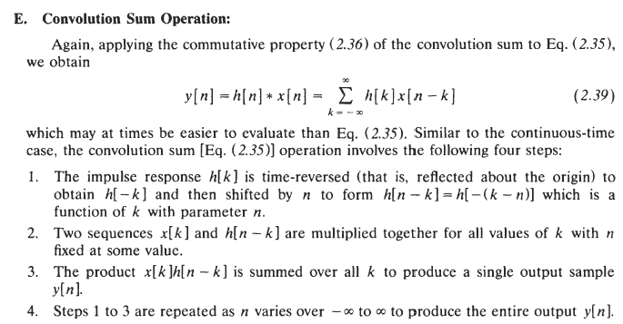

Example
Let's start with an example of convolution of 1 dimensional signal, then find out how to implement into computer programming algorithm.
x[n] = { 3, 4, 5 }
h[n] = { 2, 1 }
x[n] has only non-zero values at n=0,1,2, and impulse response, h[n] is not zero at n=0,1. Others which are not listed are all zeros.
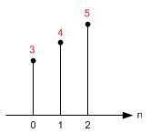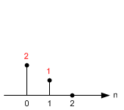
Input: x[n] Impulse Response: h[n]
From the equation of convolution, the output signal y[n] will be .
Let's compute manually each value of y[0], y[1], y[2], y[3], ...
- x[n]={3,4,5},
reflect h[n] about the origin, so h[n]={1,2}
- y[3]=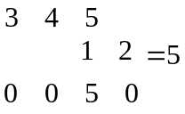
y[2]= 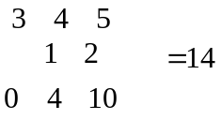
y[1]= 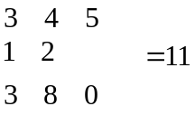
y[0]= 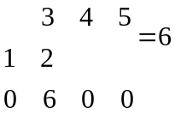
that is y[n]={6,11,14,5}
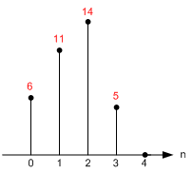
Output: y[n]
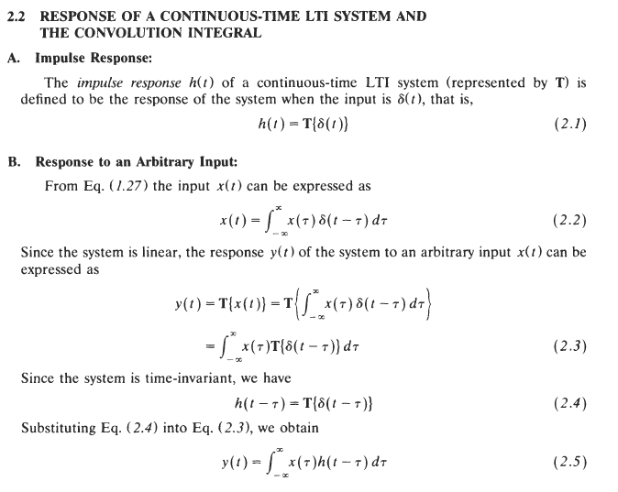
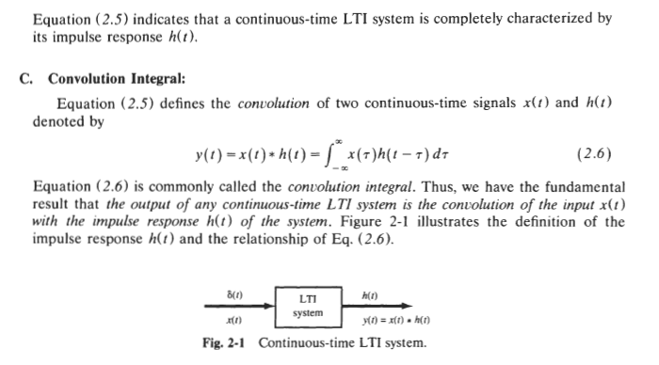
PROPERTIES OF LINEAR TIME-INVARIANT SYSTEM
For Discrete
(A) The following properties of the convolution sum are
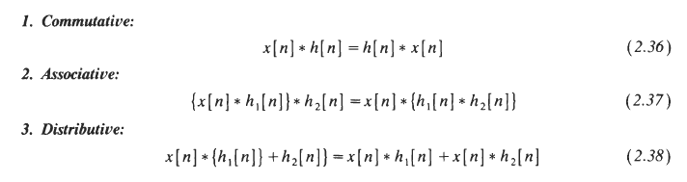
B. Systems with or without Memory:
Since the output y[n] of a memoryless system depends on only the present input x[n],
then, if the system is also linear and time-invariant, this relationship can only be of the form
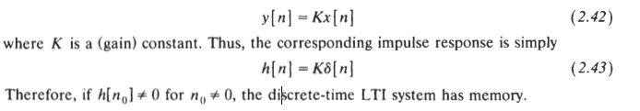

C. Causality for LTI Systems

the causality condition for a discrete-time LTI system is
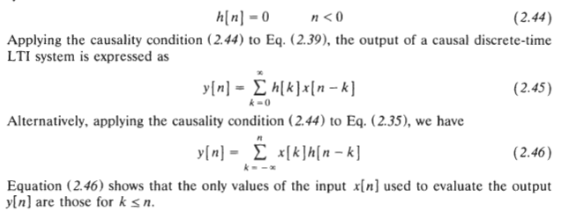

D. Stability for LTI system

a discrete-time LTI system is BIB0 stable if its impulse response is absolutely summable, that is,

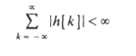
Differential and difference equations:

Differential equation is for continuous-time systems and difference equation is for discrete-time systems.
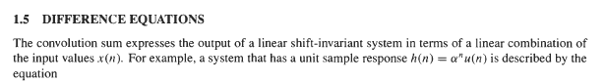
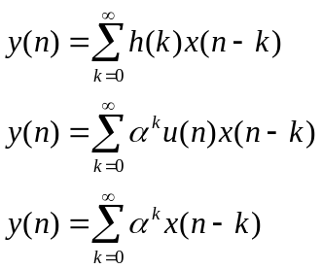 (1.9)
